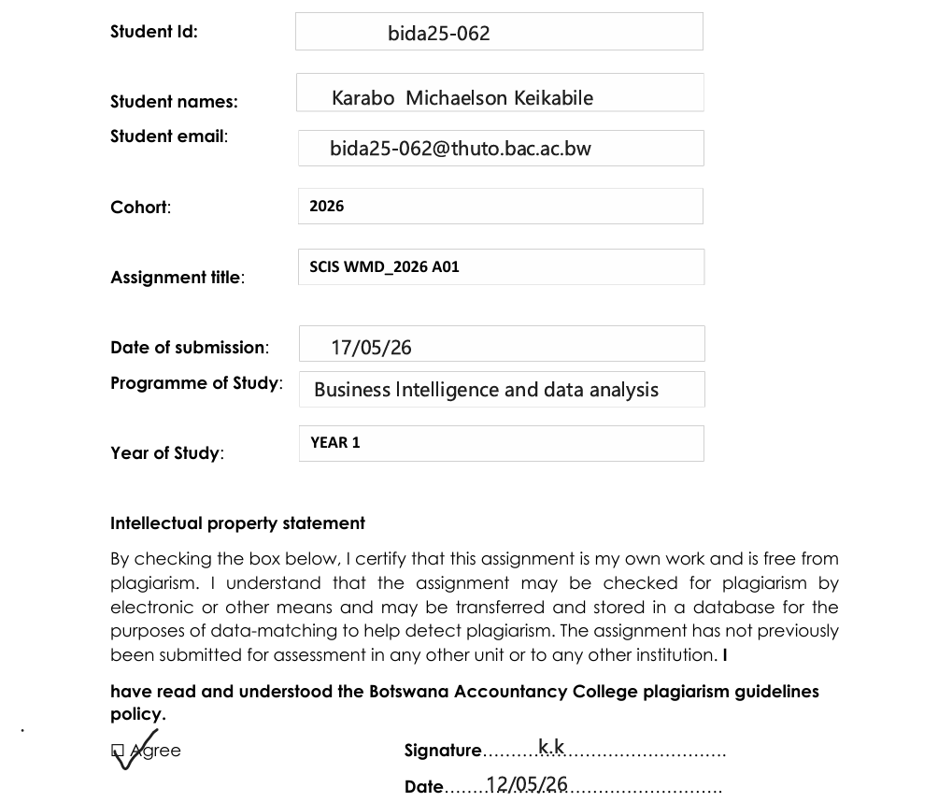
1 Website Specification
- The website targets individuals interested in fitness, intending to profit from individuals with a vision to keep fit. The objective of the business is not only to create awareness on body health and positivity but to provide a guide on how to achieve one’s fitness goals. Our goal as a business is to profit from our various health plans provided on our website. We also intend on increasing the fitness market available after careful identification of loopholes in the market.
- Our target audience is widely spread accommodating all genders aged 16-60 years. We have introduced a range of plans to accommodate for various individuals looking at one’s income level. It is open to all individuals with access to the website it does not require any complex use or understanding of digital platforms as it has been made simple and easy to navigate.
- Our website is a mix of both informational and portfolio website. Its main focus is to attract customers, provide information on the services provided at FitLife Hub as well as showcase work or skills on monitoring one’s fitness progress. To get started with our programme we have provided contacts for outreach on the website.

Information design and Taxonomy
- The visual hierarchy starts at the very top with the blue banner establishing brand identity followed by the dark navigation bar which anchors every page and ensures the user always knows where they are and where they can go. These make the website easier to navigate and browse other pages once clicked will lead to more detailed information on the particular page clicked. The hero section greets the user with a bold, full-width image and a single focused call to action Join Now removing any ambiguity about what the site wants the visitor to do next. The homepage uses the six card road to healthy life section to introduce the site six content pillars giving users a quick visual overview before they commit to exploring deeper. The site relies on content types cards and forms keeping content predictable, scannable, and easy to navigate.

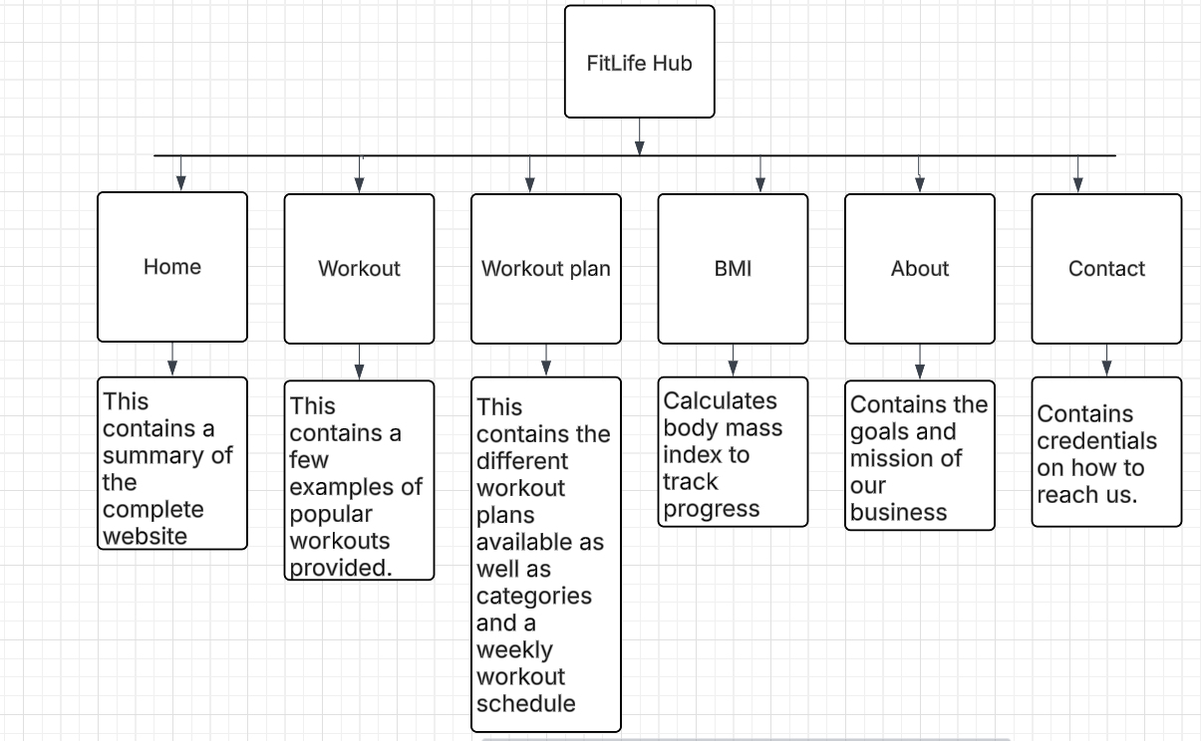
3) Home page
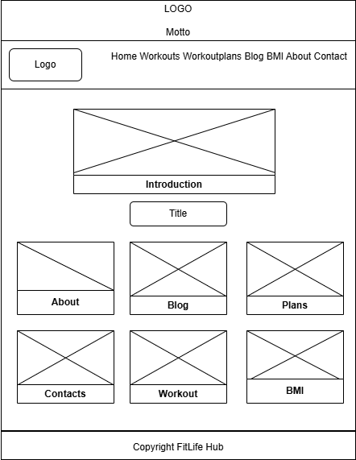

About page
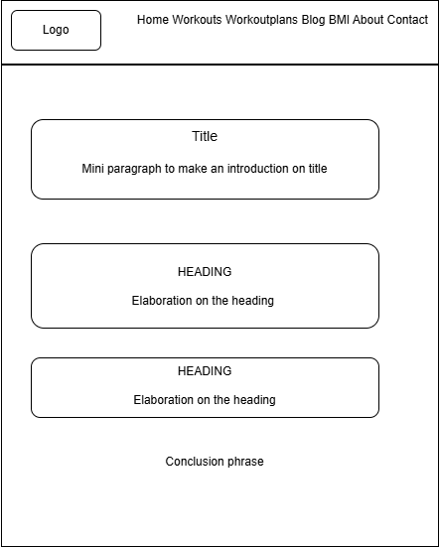

Blog page

Workout page
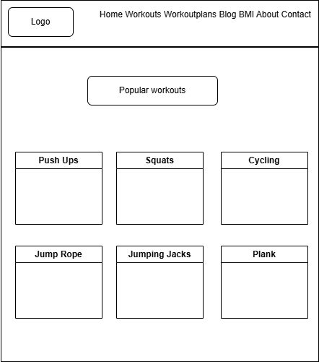
Workout plan page
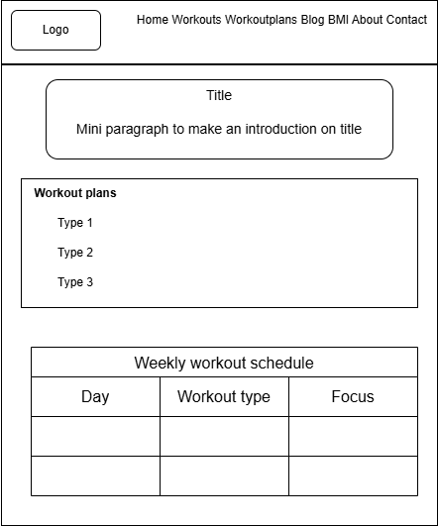

BMI page
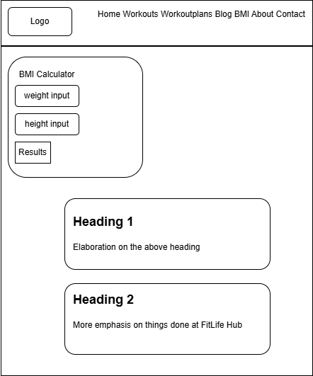
Contact Page
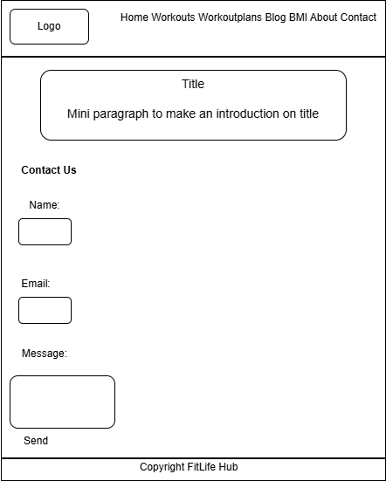

4)Technical brief
HTML-Used to structure the content of the website and cascading style sheet to style and help with the layout of the website. Development tools used visual studio code to create the code. The frontend of the website will be built using HTML5 for semantic page structure, CSS3 using Flexbox and Grid for layout, and JavaScript for interactive functionality including the hero slider, BMI calculator logic, and mobile navigation toggling. The project may optionally use a CSS framework such as Bootstrap 5 to accelerate development and ensure consistent responsiveness across all breakpoints. Extract photos from google to use on the website. Lastly, use will GitHub to publish the website.

Part B
HTML Structure
The webpage is built using HTML5 semantic elements that organize the page into clearly defined regions. Navigation, content areas and footer are kept separate to make the structure easy to read and maintain.

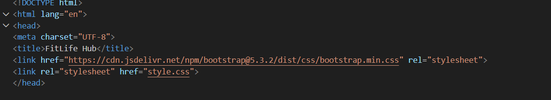
Structure start with a doctype which alerts the browser that this is a html5 document. Root element lang wraps the entire page declares the page language which is English. There is meta charset which is responsible for encoding so that text and symbols display correctly. Bootstrap is
a framework that enables ready styling layout grids and components.

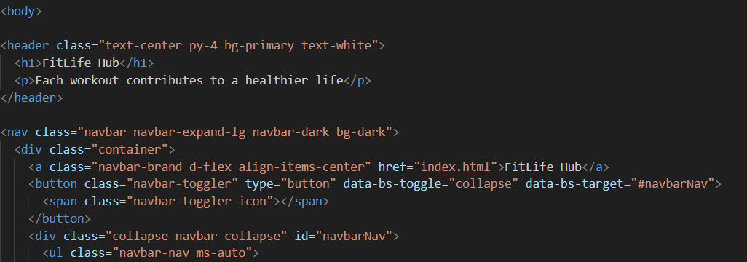
Everything the user interact with start here .The header element create a top banner section using bootstrap classes. Then follows a nav element which creates a responsive navigation bar which also use bootstrap clasess. Div elements wraps ul links that will hold up navigation links.
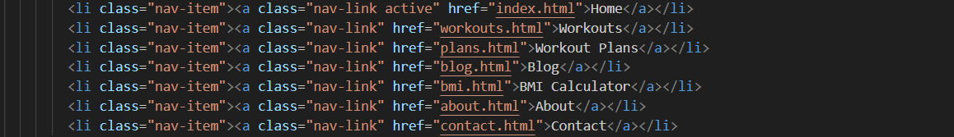

This section contains navigation links. These links items form the complete site navigation, allowing users to browse the website freely and easily.

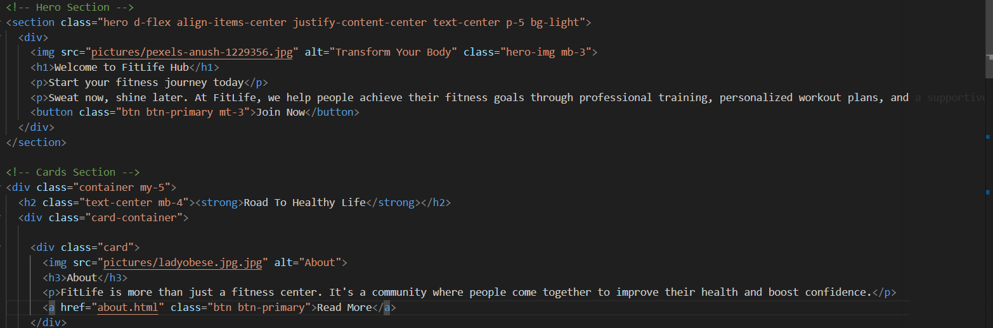

The hero section is a section with a large welcome banner with an image for the photo a h1 for the main heading paragraph tags for the descriptive text and a button for the join now call to action. Below it there is the cards section which has a division class container for layout a h2 for the section title and a division class = card container to hold the cards.
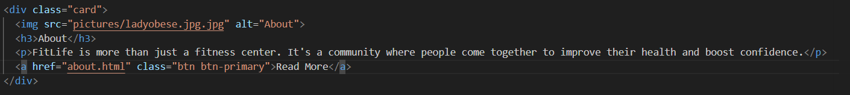
The card uses a division class card as the outer box an image to display the card image an h3 for the card title a paragraph for the description text and an anchor tag styled as a button to link the user to the other pages.
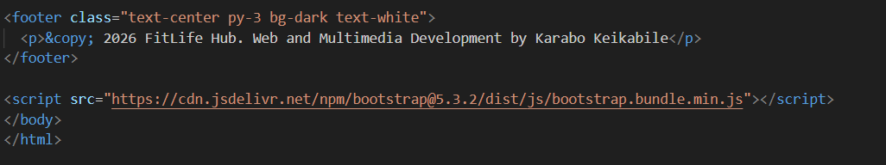
The footer tag contains the copyright notice and developer credit within a paragraph tag containing the copy symbol. At the bottom there is a script tag to load bootstrap java script for the hamburger menu to function on mobile. The body and html tags end the page.

